Title of the Extended Abstract

A. Farmer¹, B. Butcher²
1. Affiliation, Country, E-mail Address
2. Affiliation, Country, E-mail Address

BIOGRAPHY

The biography is a short, informative text, providing descriptive information about the author(s), useful to the reader, of no more than 100 words.

Text of the biography should be 10pt Times New Roman font, single-spaced and fully justified. A single line space should be left below the title ‘BIOGRAPHY’. Simply highlight this descriptive text and replace with your words.

SUMMARY

The summary is a short, informative summary of no more than 200 words. References should not be cited. The summary should not simply list the topics covered in the paper, but should:
- state the scope and principal objectives of the research,
- describe the methods used,
- summarise the results, and
- state the principal conclusions.

Text of the summary should be 10pt Times New Roman font, single-spaced and fully justified. A single line space should be left below the title ‘SUMMARY’. Simply highlight this descriptive text and replace with the words of your summary. Leave a single line space above the key words listed below.

Key words: 1 to 5 key words in 10pt Times New Roman, separated by commas; these will assist in the cross-indexing of the article.

INTRODUCTION

The purpose of the introduction is to tell readers why they would want to read what follows. This section should provide sufficient background information to allow readers to understand and evaluate the paper’s results. The introduction should:
- present the nature and scope of the problem,
- review the pertinent literature (within reason),
- describe the method of investigation, and
- describe the principal results of the investigation.

Recall, all text in the main body of the extended abstract should be 10pt Times New Roman font, single-spaced and justified. Main headings are left justified, in capital letters using 10pt Times New Roman Bold font. Sub-headings are left justified and typed in 10pt Times New Roman Bold font.

To enter your introduction, highlight the above paragraphs and replace with your text.

METHOD AND RESULTS

There is flexibility as to the naming of the section (or sections) providing information on your method and results. The methodology employed in the work must be described in sufficient detail or with sufficient references so that a competent geophysicist could duplicate the results.

Before beginning to write, organise your material carefully. Include all the data necessary to support your conclusions, but exclude redundant or unnecessary data.

Choose the active voice more often than the passive. Use the first person, not the third person, and do not use "we" when "I" is more appropriate.

Figures and Tables
The results of experiments can be presented as tables or figures. Selective presentation of results is important. Redundancy should be avoided.

Figures may be interspersed within the results section of the extended abstract, or they can be appended to the end of the written text. Figures can be imported from a number of graphical formats. Figures may be black & white or full colour. Note that if figures are to be interspersed within text, they should be no wider than 7 cm.

Tables can be created within Word. As noted for figures above, if a table is to be placed within the text, it can be no wider than 7 cm.

Figures and tables should be numbered according to the order they are referenced in the paper and should be referred to in the text by their number (as Figure XX or Table YY).

Do not make use of cross-references! Keep all figures “In Line with Text”!

Captions
Captions should be explicit enough that the significance of the figure or table can be understood by the reader without reference to the text. Details appearing in figure and table captions should not be restated in the text. The inclusion of detailed parameters in figure captions can improve the smooth flow of the main text.

Figure and table captions should be placed directly beneath the relevant figure or table and should be labelled consecutively. The caption should be typed in 10pt Times New Roman Bold font. Again spell out the word 'Figure' in full. An example figure follows.

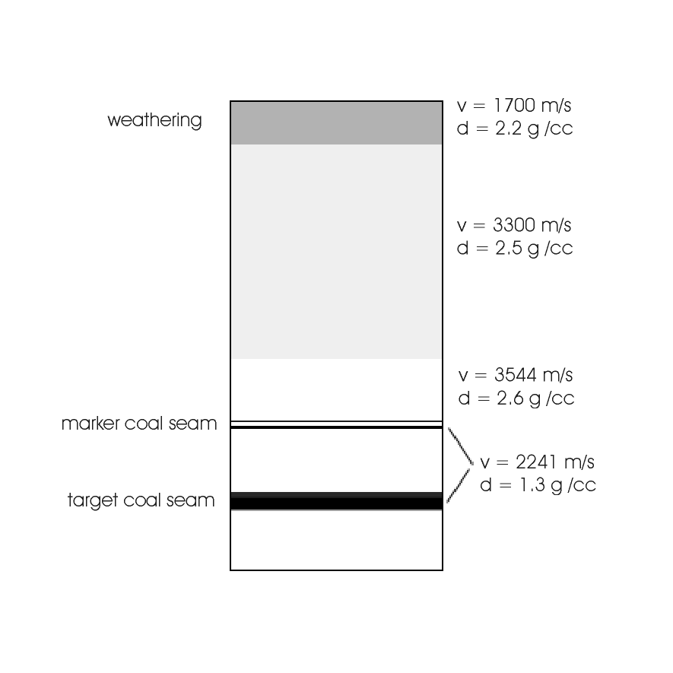
Figure 1. Geological model used as basis for seismic modelling. The vertical extent is 150 m. The velocity (v) and density (d) are shown for each layer.

Do not make use of cross-references! Type out, “Figure XX. This is the caption.” below figures and tables. Keep all figures “In Line with Text”!

Equations
Equations should be numbered in parenthesis e.g. (1) consecutively through the text. An example equation follows.

(1)

When referring to the equation, spell out the word 'Equation' in full. Define all constants and variables in the equation, and use SI units.

CONCLUSIONS

This section should include:
- the principles, relationships, and generalisations inferred from the results,
- any exceptions to, or problems with, these principles, relationships and generalisations,
- agreements or disagreements with previously published work,
- theoretical and practical implications of the work, and
- conclusions drawn.

ACKNOWLEDGMENTS

Acknowledgments are optional. They should acknowledge any significant contributions made by people or organisations to the work presented in the extended abstract.

REFERENCES

Where a reference appears as part of a sentence, it should show the authors’ names, followed by the year of publication in parentheses. This example refers to the work of Hendrick and Hearn (1999). Where the full reference is parenthesised it should appear as follows (Hendrick and Hearn, 1999). When reference is made in the text to work by three or more authors, only the first author’s name should be used, followed by et al.

A list of references must appear at the end of the main body of the text. To be of real value, authors should attempt to only reference material that is readily accessible to the reader.

References should be listed alphabetically by author. Do not abbreviate journal titles. The preferred format is based on that used in Exploration Geophysics. The references should be typed in 9pt Times New Roman font. Several examples, for journal articles, conference abstracts, books and theses, follow.

Du, B., 2000, Comparison of crosswell diffraction tomography to Kirchoff migration: Exploration Geophysics, 31, 366-371.
Hendrick, N. and Hearn, S., 1999, Polarisation analysis: What is it? Why do you need it? How do you do it?: Exploration Geophysics 30, 177-190.
Leaney, W.S., 1990, Parametric wavefield decomposition and applications: 60th Meeting, SEG, San Francisco, Expanded Abstracts, 1097-1100.
Press, W.H., Flannery, B.P., Teukolski, S.A., and Vetterling, W.T., 1992, Numerical recipes in Fortran77 2nd edition - The art of scientific computing: Cambridge University Press.
Zhou, B., 1988, Crosshole resistivity and acoustic velocity imaging: 2.5-D Helmholtz equation modeling and inversion: Ph.D. Thesis, University of Adelaide.

Note: No wrapping / column / section / page breaks are to be used! Please make use of the styles within the document to ensure consistency in the formatting?

Keep all figures “In Line with Text”!

