Title of the Innovation Abstract
A. Farmer¹, B. Butcher²
1. Affiliation, Country, E-mail Address
2. Affiliation, Country, E-mail Address

Text. The Innovation Abstract offers a unique opportunity to share your expertise and showcase your groundbreaking ideas, technological developments, innovative solutions and breakthrough research highlights. Such Innovation Abstract will be oriented technologies and solutions and can be at any Technological Readiness Levels. They are as such expected to be more commercial in nature. But they can’t be solely a promotional material. Acceptance or otherwise of an Innovation Abstract will be at the sole discretion of the Conference’s Organising Committee whose decision is final. The Innovation Posters will be displayed in the Special Session ‘Innovations & Investments Alley’ at the conference venue and visible to industry experts, technology incubators, angel investors and venture capitalists. The main author, or her/his nominated party, of an accepted abstract will be presented with the opportunity to also present a 5 min ‘Speed Talk’ of her/his development.
The abstract must be in English and of one (max 2) page including a figure or image/graphic. All text in the main body of the abstract should be 12pt Times New Roman font, single-spaced and justified. Main headings are left justified, in capital letters using 12pt Times New Roman Bold font. Sub-headings are left justified and typed in 10pt Times New Roman Bold font.
There is flexibility as to the naming of section (or sections) if such are necessary in providing information on your development. But keep things simple and impactful to catch the attention of your target audience. The methodology employed in the development must be described in sufficient detail or with sufficient references to avoid to be perceived as ‘voodoo’ geophysics.
Before beginning to write, organise your material carefully. Include all the data necessary to support your conclusions, but exclude redundant or unnecessary data.
Choose the active voice more often than the passive. Use the first person, not the third person, and do not use "we" when "I" is more appropriate.
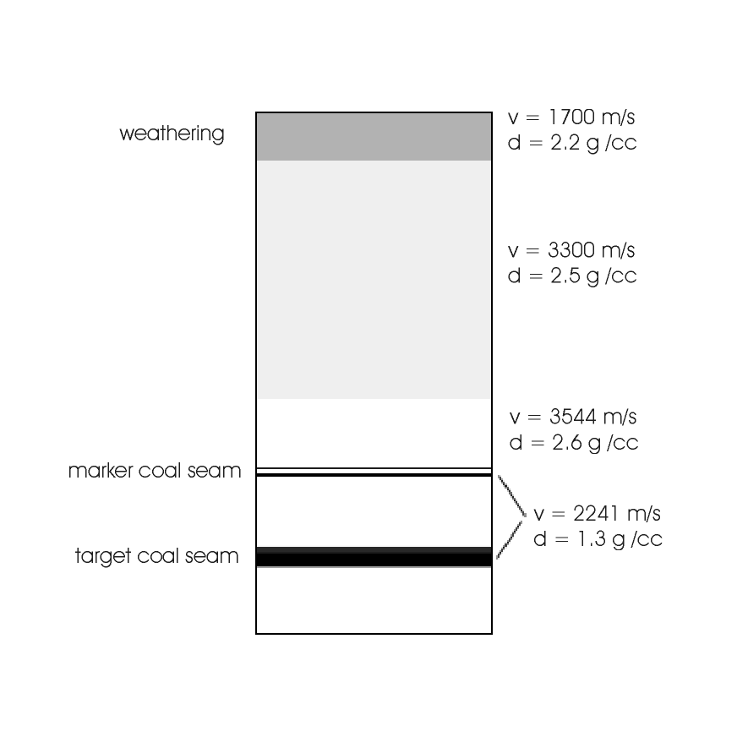
The results of developments can be presented as tables or figures or images/graphics. Selective presentation of results is important. Redundancy should be avoided. Illustration may be interspersed within the text of the abstract (inc. squared or wrapped through if effective and appropriate), or they can be appended to the end of the written text. Figures can be imported from a number of graphical formats. Figures may be black & white or full colour. Tables can be created within Word. Figures and tables should be numbered according to the order they are referenced in the text and should be referred to in the text by their number (as Figure XX or Table YY). Do not make use of cross-references. Captions should be explicit enough that the significance of the figure or table can be understood by the reader without reference to the text. Details appearing in figure and table captions should not be restated in the text. The inclusion of detailed parameters in figure captions can improve the smooth flow of the main text. Figure and table captions should be placed directly beneath or on the side of the relevant figure or table and should be labelled consecutively. The caption should be typed in 10pt Times New Roman Bold font. Again, spell out the word 'Figure' in full.

Figure 1. Geological model used as basis for seismic modelling. The vertical extent is 150 m. The velocity (v) and density (d) are shown for each layer.

Equations should be numbered in parenthesis e.g. (1) consecutively through the text. An example equation follows: (1). When referring to the equation, spell out the word 'Equation' in full. Define all constants and variables in the equation, and use SI units.

Acknowledgments. are optional and should acknowledge any significant contributions made by people or organisations to the work presented in the extended abstract.

Reference. Where it appears as part of a sentence, it should show the authors’ names, followed by the year of publication in parentheses. This example refers to the work of Hendrick and Hearn (1999). Where the full reference is parenthesised, it should appear as follows (Hendrick and Hearn, 1999). When reference is made in the text to work by three or more authors, only the first author’s name should be used, followed by et al. A list of references must appear at the end of the main body of the text. To be of real value, authors should attempt to only reference material that is readily accessible to the reader. References should be listed alphabetically by author. Do not abbreviate journal titles. The preferred format is based on that used in Exploration Geophysics. The references should be typed in 9pt Times New Roman font. Several examples, for journal articles, conference abstracts, books and theses, follow:
Du, B., 2000, Comparison of crosswell diffraction tomography to Kirchoff migration: Exploration Geophysics, 31, 366-371.
Hendrick, N. and Hearn, S., 1999, Polarisation analysis: What is it? Why do you need it? How do you do it?: Exploration Geophysics 30, 177-190.
Leaney, W.S., 1990, Parametric wavefield decomposition and applications: 60th Meeting, SEG, San Francisco, Expanded Abstracts, 1097-1100.
Press, W.H., Flannery, B.P., Teukolski, S.A., and Vetterling, W.T., 1992, Numerical recipes in Fortran77 2nd edition - The art of scientific computing: Cambridge University Press.
Zhou, B., 1988, Crosshole resistivity and acoustic velocity imaging: 2.5-D Helmholtz equation modeling and inversion: Ph.D. Thesis, University of Adelaide.

